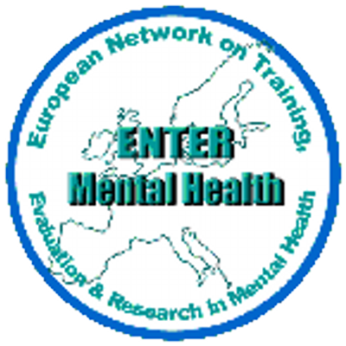 | ENTER Conference 2025  In collaboration with  School of Nursing and Midwifery  Trinity College Dublin  Ireland | 
Building Trauma Informed Societies: Current challenges for mental health.
19th June 2025

ABSTRACT SUBMISSION FORM

Abstract Title
Type (i.e. oral or poster)
Theme (from suggested conference areas)
Name of presenting author(s)
Author(s) name
Address/Institution
Country
Phone
Email
AV requirements (laptop/projector screen provided): e.g. Internet
Abstract: (Not to exceed 250 words, research studies should include objective, methodology, results, and conclusions).
References:
maximum of 2 references
Bio (max 50 words)

Please send this as an attachment by email to entermentalhealth@gmail.com
The closing date for applications is 28th February 2025.

